

ALEX EKWUEME FEDERAL UNIVERSITY NDUFU-ALIKE
PMB 1010 ABAKALIKI EBONYI STATE.
A TECHNICAL REPORT ON
STUDENTS INDUSTRIAL WORK EXPERIENCE SCHEME (SIWES)
AT
BENNY’S AFFORDCARE WALK-IN CLINIC.
PLOT 2, IVORY HEIGHT ESTATE PLAZA, ENEKA RD, OFF ENEKA LINK ROAD, PORT HARCOURT 500272, RIVERS·8.7 KM
BY
OGUIKE DIVINE CHIAGOZIE
2022/BS/21504
COURSE CODE: MCB 302
LEVEL: 300L

SUBMITTED TO THE DEPARTMENT OF MICROBIOLOGY
FACULTY OF BIOLOGICAL SCIENCE
IN PARTIAL FULFILMENT FOR THE AWARD OF BARCHELOR OF SCIENCE (B.SC) IN MICROBIOLOGY

APRIL, 2025 - SEPTEMBER, 2025.

CERTIFICATION
This is to certify that this report is a detailed account of the Student Industrial Work Experience (SIWES) undertaken by Oguike Divine Chiagozie with the matriculation number 2022/BS/21504 at Benny’s Affordcare walk-in clinic, Plot 2, Ivory Height Estate Plaza, Eneka Rd, off Eneka Link Road, Port Harcourt 500272, Rivers·8.7 km.

Oguike Divine Chiagozie -------------------- --------------------
(Name of Student) Signature Date

Dr E. N. onu -------------------- --------------------
(SIWES Coordinator) Signature Date

Dr O. C. Onwa -------------------- --------------------
(HOD Dept. Of Microbiology) Signature Date

Prof. Celestine Afiukwa -------------------- --------------------
(Dean Faculty of Biological Science) Signature Date

DEDICATION
In humble gratitude, I dedicate this SIWES report to the Almighty, the source of wisdom and strength. To the entire family of Mrs. Oguike jacinta, your unwavering support fueled my growth. To the dedicated staff at Benny’s Affordcare walk-in clinic your mentorship has been invaluable. To the vibrant community in the Microbiology department, thank you for the collaborative spirit that enriched this journey.

ACKNOWLEDGEMENT
I extend my deepest acknowledgements, first and foremost to the Almighty for His unwavering guidance throughout my Industrial Training journey. Gratitude is also due to the Director of Benny’s Affordcare walk-in clinic.Plot 2, Ivory Height Estate Plaza, Eneka Rd, off Eneka Link Road, Port Harcourt 500272, Rivers·8.7 km, for the invaluable opportunity. Special appreciation goes to my diligent supervisor, Scientist Amaka, and the entire staff of the organization for their support and collaboration. To my mum, Mrs. Oguike Jacinta, and my siblings, your unwavering encouragement has been my pillar of strength.

ABSTRACT
SIWES can be a valuable tool in making learning more engaging and provided unique opportunities for learning certain concepts, including legal concepts into a more realistic and relevant context. SIWES helps Students to understand the Practical aspect of what they are studying in the university, thereby enabling them to have a deeper understanding of their field of study and being able to defend themselves whenever they are called to do so.
Research studies have shown that there is a significant increase in participant’s factual knowledge and conceptual understanding after participation in a well-designed SIWES training program.

TABLE OF CONTENTS

CERTIFICATION ii
DEDICATION iii
ACKNOWLEDGEMENT iv
ABSTRACT v
TABLE OF CONTENTS vi
CHAPTER ONE 1
PURPOSE OF SIWES TRAINING 1
FUNCTION OF THE SIWES UNIT 3
OBJECTIVES OF SIWES 3
BRIEF HISTORY OF BENNY’S AFFORDCARE WALK-IN CLINIC. 4
ORGANIZATIONAL CHART OF BENNY’S AFFORDCARE WALK-IN CLINIC 5
BASIC EQUIPMENTS IN THE LABORATORY AND THEIR FUNCTIONS 6
RECEPTION AND REGISTRATION 12
CHAPTER THREE 14
ACTIVITIES DURING THE PROGRAMME IN DETAILS 14
PROCEDURE (For collection of venous veins): 15
SEROLOGY/IMMUNOLOGY SECTION 22
V. PREGNANCY TEST {Rapid Method} 30
VI. VENEREAL DISEASE RESEARCH LABORATORY {VDRL} 32
PROCEDURE: 32
OBSERVATION / RESULT: 33
VIII. MALARIA PARASITE TESTING (CASSETTE METHOD) 35
PROCEDURE: 36
CLINICAL CHEMISTRY SECTION 37
URINALYSIS 38
MACROSCOPIC EXAMINATION OF URINE 38
BIOCHEMICAL EXAMINATION OF URINE 39
MICROSCOPIC EXAMINATION OF URINE 41
BLOOD SUGAR TEST 45
TYPES OF BLOOD SUGAR TEST 46
PROCEDURE: 46
REFERENCE RANGE 47
MICROBIOLOGY SECTION 48
CHAPTER FOUR 54
SUMMARY OF TRAINING EXPERIENCE 54
DIFFICULTIES ENCOUNTERED 54
WAYS OF IMPROVING THE PROGRAMME 55
CHAPTER FIVE 56
CONCLUSION 56
REFERENCES 57

CHAPTER ONE

INTRODUCTION TO THE TRAINING PROGRAM

PURPOSE OF SIWES TRAINING

The Students Industrial Work Experience (SIWES) is an appreciable skill program designed to equip student to the real-life working experience. This scheme is a program involving universities, polytechnics and technical colleges and students of various institutions in the country. The Students Industries Work Experience Scheme (SIWES) is funded jointly by Industrial Training Fund (ITF). The training lasts for a period of six months or one year. The theory and practical aspect are being joined together in the program in order to find out how things are being done.
I was employed as an industrial training student by Benny’s Affordcare walk-in clinic of which I was with them from 1st September, 2023 to 13th February, 2024. During this period, I learnt, observed, made reports of daily activities, procedures and work progress carried out in the laboratory. I was tested on the knowledge and experience I had obtained so far by my Industrial based supervisor of which I was tested anytime. I had to be ready always. In the light of the above, this report is therefore, a detailed illustration of the nature of daily activities and work carried out in my place of training. It comprises of the knowledge I acquired, problems encountered, and possible solutions and of course conclusion.
BRIEF HISTORY OF SIWES
Student’s industrial work experience scheme (SIWES) was established by industrial training fund (ITF) in the year 1973 to solve the problem of lack of adequate proper skills for employment of tertiary institution graduates by Nigerian Industries. The students Industrial Work Experience scheme (SIWES) was founded to be a skill training program to help expose and prepare students of universities, polytechnics, and college of education for the industrial work situations to be met after graduation. This scheme serves as a smooth transition from the classroom to the world of work and further helps in the application of knowledge. The scheme provides students with the opportunity of acquainting and exposing themselves to the experience required in handling and managing of equipment and machinery that are usually not made available in their institution.
Over the years, SIWES has contributed immensely to building the common pool of technical and allied skills available in the Nigeria economy which are needed for the nation’s industrial development.
Before this scheme was established, there was a growing concern and trend noticed by industrialist that graduates of higher institution lacked sufficient practical background for employment. It used to be that students who got into Nigerian Universities to study science and technology were not trained in the practical know-how of their various fields of study. As a result, they could not easily find jobs due to lack of working experience.
Therefore, the employers thought that theoretical education going on in the higher institutions was not responsive to the needs of the employers of labor. This was a huge problem for thousands of Nigerians until 1973. It is against this background that the fundamental reason for initiating and designing the scheme by the fund in 1973/74 was introduced.

The ITF organization made a decision to help all interested Nigerian students and established the SIWES program. It was officially approved and presented by the federal in 1974.
Since then Participation in SIWES has become a necessary pre-condition for the award of Diploma and Degree certificates in specific disciplines in most institutions for higher learning in the country, in accordance with the education policy of Nigeria.
SIWES is recommended to students of the faculties of Technology, Science, Pharmacy, Education, Environmental Design, and Management and some of Basic Medical Sciences in all colleges of Education, Polytechnics and Universities in Nigeria

FUNCTION OF THE SIWES UNIT
By the direction of National Universities Commission (NUC) and Industrial Training Fund (ITF), the unit is mandated to carry out the following functions:
- Seeking of industrial placement for undergraduate students enrolled in disciplines scheduled for participation in SIWES.
- Supervision of the student placed in the industries located within our ITF zone.
- Processing of students’ logbooks, ITF forms and industrial attachment reports upon which is based on Federal Government funding of supervision and students’ allowances.
- Fostering of close links between the university and industries participating in SIWES program.
- Provision of advisory guidance to participating students on career employment opportunities
- Monitoring of compliance with the requirements of SIWES on the part of students in eligible disciplines as a condition for graduation.
- Facilitation of disbursement of the students’ allowance to deserving students through e-payment.

OBJECTIVES OF SIWES
- Provide avenues for students to acquire industrial skills and experience during their course of study.
- Prepare students for industrial work situation they are likely to meet after graduation.
- Expose students with the opportunities to apply their educational knowledge in real work situations, thereby bridging the gap between theory and practice, and,
- To make the transition from the schooling to world of work easier through enhancing students’ contact for later job placement.

BRIEF HISTORY OF BENNY’S AFFORDCARE WALK-IN CLINIC.
Benny’s Affordcare walk-in clinic, Nigeria stands as a prominent medical laboratory that specializes in a comprehensive range of medical tests and laboratory analysis. With its incorporation under Registration Number 2216803 on July 4, 2012, the center has been committed to providing essential diagnostic services.
It is located at Plot 2, Ivory Height Estate Plaza, Eneka Rd, off Eneka Link Road, Port Harcourt 500272, Rivers·8.7 km, the registered office reflects its presence in the heart of the community. Going beyond traditional laboratory services, Benny’s Affordcare walk-in clinic extends its capabilities to include advanced diagnostic modalities such as ultrasound and X-ray, enhance its capacity to cater to diverse array of medical needs.
This progressive approach positions Benny’s Affordcare walk-in clinicas a valuable asset in the healthcare landscape, contributing to the well-being of the community it serves. For further insights into its rich history and contributions, it is recommended to explore official records or directly engage with the center for a more detailed account of its journey and impact.

ORGANIZATIONAL CHART OF BENNY’S AFFORDCARE WALK-IN CLINIC.

CHAPTER TWO
MEANING OF MEDICAL LABORATORY
A Medical laboratory is a laboratory where tests are carried out on clinical specimens to obtain information about the health of a patient to aid to diagnosis, treatment and prevention of disease
It is an office/or a room with equipment/apparatus where different tests are carried out such as diagnosis, control of diseases, and treatments. It is also designed and well equipped to practical purposes involving microscopy and identification of infection and possible treatment.
DIFFERENT SECTIONS AT BENNY’S AFFORDCARE WALK-IN CLINIC.
- Phlebotomy section
- Serology/immunology section
- Clinical chemistry section
- Microbiology section

ORIENTATION
I commenced my SIWES program on the 1st September 2023. On arrival to Benny’s Affordcare walk-in clinic., I was taken to laboratory, the section I was going to serve as a trainee. The Director (chief lab scientist) introduced me to my industrial based supervisor Scientist Amaka and the other staff working there. I was also enlightened on some laboratory apparatus and equipment and subsequent description of their uses and their working principles.

BASIC EQUIPMENTS IN THE LABORATORY AND THEIR FUNCTIONS
- MICROSCOPE: This is one of the most important equipment especially in microbiology laboratory, it’s a magnifying instrument which consists of an objective lens and eyepiece and other several parts used for focusing and magnifying objects. In clinical laboratory, it is used for viewing microorganisms present in a specimen, stool and urine sample, Etc.
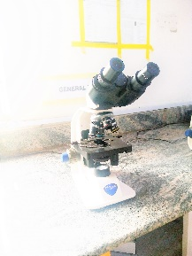
Figure 1 A microscope
- CENTRIFUGE: This is used to rapidly sediment particles such as cell, which may be suspended in a fluid. This machine exerts a centrifugal force (CF), which is greater than that of gravity, and causes particles in a fluid to sediment
.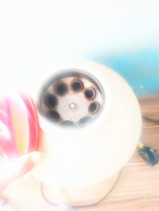
Figure 2 Centrifuge
- INCUBATOR: This is a device used to grow and maintain microbiological cultures or cell cultures. It maintains optimal temperature, humidity and other conditions such as carbon(IV) oxide and oxygen content of the atmosphere inside
.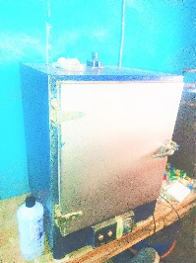
Figure 3 Incubator

- BOTTLE: They are used to store and preserve samples.
- BUNSEN BURNER: This is used for heating and exposing items to flame.
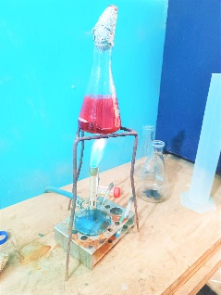
Figure 4 Bunsen burner
- MICRO-SPATULA: The spatula is used for moving small amounts of solid from place to place.
- EDTA BOTTLES:This is a container that contains an anticoagulant for storing blood samples to avoid clotting.
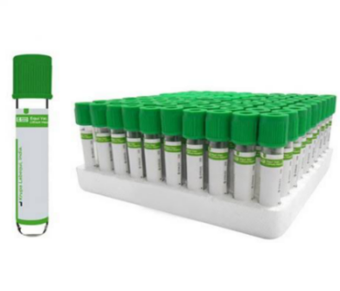
Figure 5 EDTA bottle
- MICROPIPETTE: This is used to move small and specific amount of liquid from one place to another.
- SWAP STICK: This is used for the collection of samples such as high vaginal swab (HVS), urethral swab, etc.
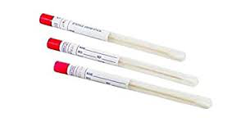
Figure 6 swap stick
- GLUCOMETER: This is used for measuring blood sugar.
- TEST TUBE RACK: It is used for holding large number of test tubes in the laboratory.
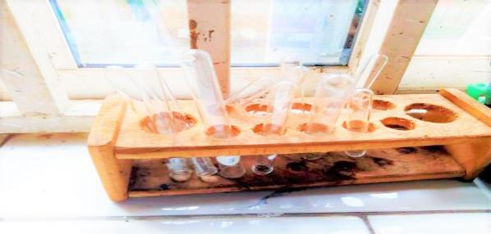
Figure 7 Test tube rack

- HEMATOCRITE READER: This is a graduated device which possesses several slots into which the capillary tube could be placed so that the spin blood that has been separated into serum at the top and the red cells at the bottom could have their level read approximately from the zero mark.
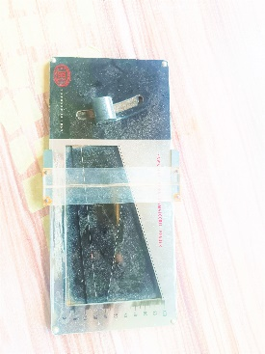
Figure 8 Hematocrit reader
- WEIGHING BALANCE: This is used for measurement.
- WIRE LOOP: It is used for streaking specimen on culture plates and it can also be used for making smear of samples on slides.
- LANCET: It is a sterile needle used to prick the thumb for the collection of blood samples.
- AUTOCLAVE: This is used for sterilizing equipment and materials by subjecting them to high-pressure steam, eliminating bacteria, viruses, and other microbes.
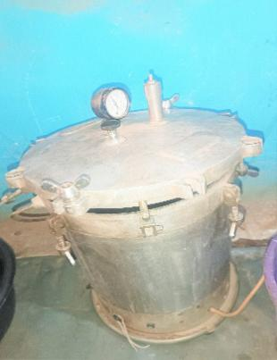
Figure 9 Autoclave
- NEEDLE AND SYRINGE: This is used for the blood collection, and storage of samples such as serum, aspirate, or ascetic fluid.
- PLASTIC TILE: This is used for widal test, blood genotype test, blood group test.
- SLIDE BOX: This is used for keeping slides.
- GLASS SLIDE: This is used for smear preparation, staining and viewing specimen under microscope.

Figure 10 Glass slide
LABORATORY SAFETY PRECAUTIONS:
- A laboratory worker can contribute to the prevention of self-infection and the infections of others. A good laboratory must take appropriate safety precautions:
- No eating, drinking, smoking, storing of food, or applying cosmetics in the laboratory/testing work areas.
- Keep the laboratory/testing site neat, clean, and free of extra materials that are not pertinent to the work.
- Decontaminate work surfaces with 10% bleach immediately after any spill of potentially dangerous material and at the end of each working.
- Wash your hands after handling infectious materials and before you leave the laboratory.
- No pipetting by mouth. It is prohibited.
- Decontaminate all contaminated waste and specimens with 10% bleach before disposal. All contaminated waste samples etc should be decontaminate, autoclaved, or incinerated as appropriate.
- Wear laboratory coats during all laboratory procedures. These coats must not be worn in non-laboratory area such as offices, libraries, staff rooms, and canteens. Contaminated clothing must be decontaminated by appropriate methods.
- Only authorized personnel are given access to laboratory areas. Laboratory doors should be kept closed when work is in progress, children must be excluded from laboratory working areas.
- Wear gloves during all laboratory procedures. After use, gloves should be removed aseptically, and disposed off with other laboratory waste. Hands must then be washed.
- Immediately report all spills, accidents and other potential exposures to infections materials to the laboratory supervisor. Appropriate medical evaluation, surveillance and treatment should be provided.

RECEPTION AND REGISTRATION
Reception is a place where people (mostly patients) are received. Here in the reception, registration is done. The reception is the first entrance, office in the laboratory section of the hospital. Here in the reception, patients, request forms from the hospital and samples (from the hospital or outside) are received.
Registration involves the input of received data from request forms to the lab register. A request form contains details of the patients which include:
- Name of patients
- Sex of the patients
- Age of the patient
- Type of sample
- Type of test required to be conducted
- Name of the Lab scientist
In the lab register after the input of data, a space is kept for result, the amount paid for the test to be carried out, etc. This register contains patient’s details for each year.

CHAPTER THREE

ACTIVITIES DURING THE PROGRAMME IN DETAILS

PHLEBOTOMY SECTION
Phlebotomy is the practice of drawing blood from patients and taking the blood specimens to the laboratory to prepare for testing. As a phlebotomy technician (phlebotomist) you are an important member of the clinical laboratory team Blood is usually taken from a vein on the back of the hand or just below the elbow. Some blood tests, however, may require blood from an artery. For some tests requiring very small amounts of blood for analysis, the technician uses a finger stick. A lancet, or small needle, makes a small cut in the surface of the fingertip, and a small amount of blood is collected in a narrow glass tube. The fingertip may be squeezed to get additional blood to surface. The amount of blood drawn depends on the purpose of the phlebotomy. The blood samples are collected from patients either through the vein or the capillary. Blood samples are collected only when the tests to be run require blood. There are two types of blood sample, namely: venous blood and capillary blood.
TITLE: COLLECTION OF BLOOD
AIM: To learn the technique for collecting capillary and venous blood.
MATERIALS: Lancet, 23G needle, 2ml- 5ml syringe, well-fitting non-sterile gloves, tourniquet, cotton wool, sealing wax, EDTA container, capillary tube.
PROCEDURE (For collection of capillary blood):
- I arranged all the apparatus needed to carry out the test.
- I put on my gloves, swabbed the puncture site (the thumb, or middle finger, or under the heel for babies) with ethanol and cotton wool. I allowed it to dry, and I did not touch the swabbed area to avoid contamination.
- I made a rapid puncture on the site with a new lancet, sufficiently deep to allow free flow of blood.
- I wiped away the first drop of blood with a dry cotton wool.
- I placed one end of a capillary tube at the punctured site and squeezed out the blood gently into the tube to fill it about ¾ (three quarters) of the tube.
- I pressed a dry piece of cotton wool on the punctured site until bleeding seizes.
- I sealed one end of the capillary tube with sealing wax and it is ready to run a test.

PROCEDURE (For collection of venous veins):
- I arranged all the apparatus needed to carry out the test, labeled the EDTA bottle for the test.
- I put on my gloves, attached a sterile needle to a sterile syringe.
- I tied a tourniquet on the patient’s upper arm to enable the veins to be seen properly seen and felt. Do not tie the tourniquet too tightly or for longer than 2 minutes.
- I asked the patient to make a fist in order to make the veins prominent.
- I used the index finger to feel for a suitable vein, selecting a sufficient and straight vein.
- I swabbed the punctured site with ethanol and cotton wool, I allowed it to dry, and I did not touch the swabbed area to avoid contamination.
- I held down the skin below the puncture site using the index finger and made a venipuncture with the bevel of the needle directed upwards in the line of the vein.
- When I had collected sufficient blood, I released the tourniquet and instruct the patient to open his or her hand fist. I removed the needle and pressed the puncture site with a dry cotton wool. I removed the tourniquet and instructed the patient to continue applying pressure to it till the bleeding stopped.
- I removed the needle from the syringe and discarded the needle in a safety box. Then, I dispensed the blood into the labeled EDTA bottle. Then, I discarded the syringe in a trash bin.
- Mix the blood well in the bottle by inverting the bottle for about 3 time 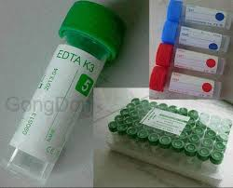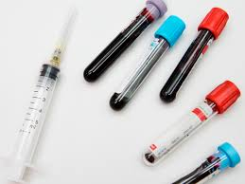
Figure 11 EDTA bottles
Fig 10 shows diagram of EDTA bottles (Ethylene diamine tetra–acetic acid), for anti-coagulated blood.
NOTE: The blood sample can put in EDTA bottle or a tube depending on the test to be ran with the sample.

HEMATOLOGY SECTION
Hematology is the study of the morphology of the blood and blood forming tissues. In the hematology section, medical professionals examine blood and blood-forming tissues to diagnose and treat diseases related to these components. This includes analyzing whole blood samples to understand and address conditions affecting the production of blood cells, hemoglobin, blood proteins, platelets, and the functioning of organs like the bone marrow, spleen, and blood vessels. The focus is on identifying and managing disorders that impact the composition and proper functioning of blood within the human body, ensuring comprehensive care for patients with hematological conditions. Some of the tests carried out in this workstation include;
- Packed cell volume
- Blood grouping

PACKED CELL VOLUME TEST (PCV)
The Packed Cell Volume (PCV) test, conducted to determine blood levels, is instrumental in calculating the Mean Cell Hemoglobin Concentration (MCHC) and Mean Cell Volume (MCV). These red cell indices are used in the investigation and screening of anemia, especially when direct measurement of hemoglobin is not feasible.
AIM: To determine the packed cell volume of blood
PRINCIPLE: Packed Cell Volume is that proportion of the blood occupied by red cells, expressed as a ratio. Anti-coagulated blood in a glass capillary tube of specified length bore size and wall thickness is centrifuged for 5 minutes to obtain a constant packing of the red cells. The PCV value is read from the scale of a micro hematocrit reader or calculated by dividing the height of the red cell column by the height of the total column of blood.
MATERIALS: EDTA Anti-coagulated blood.
APPARATUS: Lancet, gloves, sealing clay or wax, cotton wool, capillary tube, hematocrit centrifuge, micro hematocrit reader.
PROCEDURE:
- I arranged all the apparatus needed to carry out the test.
- I put on my gloves, swabbed the puncture site (the thumb) with ethanol and cotton wool.
- I allowed it to dry, and I did not touch the swabbed area to avoid contamination.
- I made a rapid puncture on the site with a new lancet, sufficiently deep to allow free flow of blood.
- I wiped away the first drop of blood with a dry cotton wool.
- I placed one end of a capillary tube at the punctured site and squeezed out the blood gently into the tube to fill it about ¾ (three quarters) of the tube.
- I pressed a dry piece of cotton wool on the punctured site until bleeding seized.
- I sealed one end of the capillary tube with sealing clay or wax
- I placed the capillary tube in the hematocrit centrifuge and spinned it for 5 minutes.
- After spinning, I read the result of the test with a micro hematocrit reader.

N/B PCV is calculated in g/dl. To find the blood percentage, divide by 3 and multiply by 6.7. Normal PCV range is 40-47%, while panic value or critical value is <21%, the donor value is >35%.
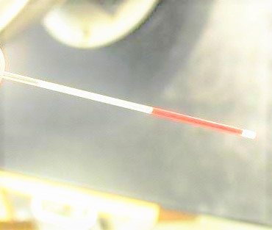
Figure 12 capillary tube
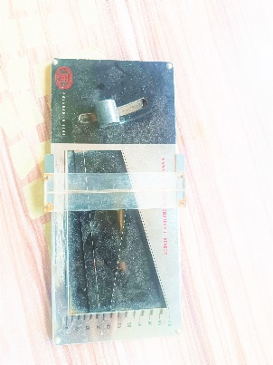
Figure 13 hematocrit reader
RESULT: To read the PCV in a hand- held micro hematocrit reader, align the base of the red cell column {above the sealant} on the 0 line and the top of the plasma column on the 100 line. Read off the PCV from scale. The reading point is the top of the red cell column.
In a similar way to Hemoglobin levels, PCV values vary according to age, gender, and altitude. Reference range;
Children at birth …………44-54%
Children 2-5 years …………34-40%
Children 6-12 years ………… 35-45%
Adult men ………… 40-54%
Adult women …………36-46%

BLOOD GROUPING (ABO GROUPING SYSTEM)
AIM: To determine the ABO grouping of blood sample
PRINCIPLE: All people belong to one of four inherited blood groups: A, B, AB, O. The letters A and B refers to the kind antigen found on an individual’s red blood cells. An Antigen is a protein on the cell which triggers an immune response, such as the formation of antibodies, against the antigens which the red blood cell lacks.
Most people also have an inherited condition of the red blood cells known as the Rhesus factor, or antigen D. when the antigen is present, a person’s blood type is designated Rhesus positive. When antigen D is missing, the blood type is classified Rhesus negative.
MATERIALS: Blood sample, Monoclonal antibodies (Anti A, B, AB and D), Alcohol swap, Methylated spirit, Applicator stick, Grouping tile, Lancets.
PROCEDURE:
- I cleaned the grouping tiles and wiped off water till its dry.
- I placed a drop of blood by pricking the finger with lancet, in three different areas.
- Then I labelled the areas as A, B, AB and D
- I Placed anti-A in area A, anti-B in area B, anti-AB in area AB and anti-D in area D
- I mixed the contents of each circle with separate applicator stick and spread to fill the whole area of the individual circle.
- I rocked the tile for few seconds and observed for agglutination.

ANTI A | ANTI B | AB | ANTI D | RESULT
+ | - | + | + | A positive
+ | - | + | - | A negative
- | + | + | + | B positive
- | + | + | - | B negative
- | - | - | + | O positive
- | - | - | - | O negative
+ | + | + | + | AB positive
+ | + | + | - | AB negative
RESULT:
Keys


Fig Anti-sera A, B, AB and O

+ stands for agglutination
- Stands for no agglutination
Anti-sera A = Blue in colour
Anti-sera B = yellow in colour
Anti-sera AB = purple or colourless
Anti-sera D = straw or colourless
Rh stands for Rhesus factor

SEROLOGY/IMMUNOLOGY SECTION
This section deals with tests which involve antigen – antibody reaction in the human immune system. Plasma (upper part of blood in EDTA bottle containing an anticoagulant) or serum (the upper part of blood in syringe without an anticoagulant is used for test under this section though urine can also be used for pregnancy test. Some of the tests usually carried out in this section are:
- Widal test
- Hepatitis B – surface Antigen test
- Hepatitis C (HCV) virus
- Helicobacter pylori test
- Pregnancy test
- Venereal disease research laboratory (VDRL) test
- Retroviral screening (RVS) test
- Malaria parasite test

- WIDAL AGGLUTINATION TEST
Typhoid fever is caused by a bacillus called Salmonella typhi. The organism is found in the intestine, blood and the urine and is transmitted by infected food or water. In the early stage of the disease there is rising fever with headache, a neutropenia and the patient may become very ill. There is ulceration of the intestine which may lead to perforation, neutrophil develops.
AIM: To investigate the presence of Salmonella typhi and para typhi in the serum of patient.
MATERIALS: Salmonella (widal) antigens, white tile, stirrer, patient serum.
PRINCIPLE: The main principle of widal test is that if homologous antibody is present in patients serum, it will react with respective antigen in the reagent and gives visible clumping on the test card.
PROCEDURE:
- Centrifuge the patients’ blood and separate the serum.
- Place a drop of the typhi O and H on a clean tile.
- Place a drop of the para typhi on a clean tile. Note: Typhi O and para typhi OA, OB, OC should be on a line and also typhi H and para typhi AH, BH and CH on the downward line.
- Then add a drop of patient’s serum into each hole.
- Mix it together and then rock to give a reaction
- Check if there is any reaction and record your findings.
RESULT
Reactive: visible agglutination on spot H and others indicate the present of Salmonella antibodies.
Non-reactive: no visible agglutination indicates absence of Salmonella antibodies
Widal test: Positive
Highly reactive……………………………….1:320 (agglutination reaction before 60 seconds)
Very reactive………………………………….1:160 (agglutination reaction before 120 seconds)
Reactive ………………………………………1:80 (agglutination reaction before 180 seconds)
Widal test: Negative
Non-significant……………………………….…1:40
Non-significant………………………………….1:20
Not reactive…………………………..………….Nil

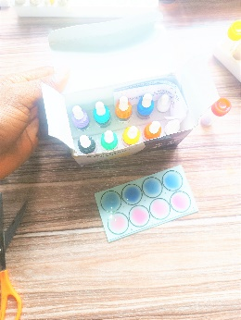
Figure 14 Widal kit and test
PRECAUTIONS:
- Shake antigen vial well before use
- Serum should be clear.
CLINICAL SIGNIFICANCE
Widal test is a serological test used in the diagnosis of typhoid and paratyphoid due to body invasion by Salmonella spp. It is caused by drinking dirty water.

- HEPATITIS B SURFACE ANTIGEN (HBsAg) TEST
HBsAg is a rapid immune-chromatographic test for the qualitative detection of Hepatitis B surface Antigen in human serum/plasma, it can be used for prenatal or transfusion screening, and during acute infection or chronic carriage of the Hepatitis B virus. Early detection of infection is essential for rapid initiation of adequate treatment.
AIM: To detect the presence of hepatitis B virus in a patient’s serum using HBsAg strip.
PRINCIPLE: HBsAg is a rapid qualitative test solid phase. Two sites sandwich immunoassay for the qualitative detection of hepatitis B surface antigen in the blood. The membrane pre-coated with an ant-HBS antibodies on the test line region of device. The whole blood, serum or plasma specimen react with anti-HBS antibodies conjugated particles. The mixture migrate upward the membrane chromatographically by capillary action to react with anti-HBS antibodies on the membrane and generate a coloured line. The presence of two coloured line in the region indicates positive result while the presence of one line (control area) shows negative.
MATERIALS: HBsAg test strip, centrifuge, hand gloves, patient’s blood.
PROCEDURES:
- Centrifuge the blood sample to obtain the serum.
- When ready to test, open the pouch and remove the strip.
- Immerse the trip into the sample with the arrow end pointing towards the sample, do not allow maximum line to touch the sample.
- Take the strip out after 8-10 seconds, and lay on flat surface.
- Read result in 10-15mins
OBSERVATION: Two lines were shown on the result window.
INTERPRETATION OF RESULT:
Positive/reactive: Coloured line appeared in both control and patient test region.
Negative/unreactive: One coloured line appeared in the control region and no coloured line appeared in patient’s test region.
Invalid result: If there is no coloured line in the control & even if the coloured line appears in the patient’s test region, it is termed invalid.
CONCLUSION: The presence of HBV-antigen was detected using HBsAg test strip method.
PRECAUTIONS:
It was ensured that the test stayed for about 10minutes so as to obtain good result.
It was ensured that hemolysed blood was not used.
It was ensured that the test strip was not placed on rough surface area.
CLINICAL SIGNIFICANCE:
This test helps for the diagnosis of hepatitis B virus. The virus causes the most serious form of viral hepatitis. Viral hepatitis is a systemic disease primarily involving liver. Most cases of acute viral hepatitis are caused by hepatitis B virus. Hepatitis B virus is spread through blood, body fluid, and sexual means. The persistency of the virus in chronic carrier can years later, develop liver cirrhosis and liver cancer.

- HEPTITIS C (HCV) VIRUS
HCV spread by blood to blood contact but HCV is not as easily transmitted as Hepatitis B. only small number of the virus are excreted and circulate in the blood.
AIM: To detect Hepatitis C virus (HCV) in a given blood sample.
PRINCIPLE: Hepatitis C virus testing detects antibodies or viral RNA in the blood, indicating exposure or active infection.
MATERIALS: HCV test strip, centrifuge, hand glove and blood sample.
PROCEDURE:
Centrifuge the blood sample to obtain the serum.
When ready to test open the pouch and remove the strip.
Immerse the strip into the sample with the arrow end pointing towards the sample. Do not immerse past the maximum line. Take strip out after 8-10 seconds.
Read results in 10-15mins.
INTERPRETATION OF RESULTS
RESULT | INTERPRETATION
The presence of bands on both the test and control field | Positive
The presence of a single band at the control field | Negative
The presence of no visible bands | Invalid

CLINICAL SIGNIFICANCE:
This test helps for the diagnosis of hepatitis C virus. The virus causes the most serious form of viral hepatitis. Viral hepatitis is a systemic disease primarily involving liver. Most cases of acute viral hepatitis are caused by hepatitis C virus. Hepatitis C virus is spread through blood, body fluid, and sexual means. The persistency of the virus in chronic carrier can years later, develop liver cirrhosis and liver cancer.

- HELICOBACTER PYLORI TEST
H-pylori is a type of bacteria that grows in the digestive system tract and has the tendency of attacking the stomach lining which protects your stomach. It can damage the tissue in your stomach and the first part of your small intestine (the duodenum). This can cause redness and soreness. Many persons have it. It’s a main cause of stomach ulcer. Untreated, long-term H-pylori infection can lead to Stomach Cancer.
H-pylori one step test device (whole blood/serum/plasma) is a qualitative membrane strip based immunoassay for the detection of H-pylori antibodies in whole blood, serum or plasma.
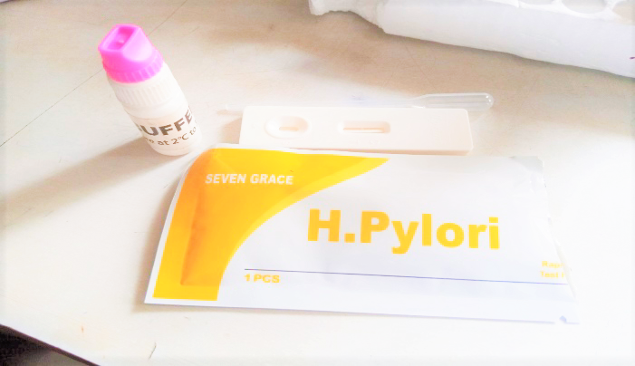
Figure 15 H. Pylori rapid kit
PRINCIPLE: H. pylori testing involves identifying the presence of antibodies or antigens associated with Helicobacter pylori. Serological tests detect specific antibodies in the blood, indicating a current or past infection.
MATERIALS: Test cassette, Disposable specimen droppers, Buffer, Specimen collection container, Centrifuge (for serum only)
PROCEDURES
- Place the test device on a clean and level surface.
For serum or plasma specimen: Hold the dropper vertically and transfer 3 drops of serum or plasma to the provided opening of the test device.
For Venipuncture whole blood specimen: Hold the dropper vertically and transfer 2 drops of whole blood to the provided opening of the test device, then add 1 drop of buffer.
- Wait for the red line(s) to appear. The result should be read at 10 minutes.
NOTE: low levels of H-pylori antibodies might result in a faint line appearing to the test region (T) after extended period of time; therefore, do not interpret the result after 30 minutes.
RESULTS INTERPRETATION
POSITIVE: Two distinct red lines appear. One line should be in the control region (C) and another line should be in the test region (T).
NEGATIVE: One red line appears in the control region (C). No apparent red line appears in the test region (T).
INVALID: Control line fails to appear. Insufficient specimen volume or incorrect procedural techniques are the most likely reasons for control line failure. Review the procedure and repeat the test with a new test device. If the problem persists, discontinue using the test kit immediately and contact your local distributor.
PRECAUTIONS
- Ensure you wear protective wears such as laboratory coats, disposable gloves when the specimen are assayed.
- Handle all specimen carefully
Follow the standard procedures for proper disposal of specimens

PREGNANCY TEST {Rapid Method}
HCG pregnancy test strip is a rapid test method used in detecting if a woman is pregnant or not. It is an in-vitro diagnostic test for the qualitative detection of human chorionic gonadotropin (HCG) in serum and urine. This test is a highly sensitive chromatographic immunoassay that detects early pregnancy, with results obtained in just about 10 minutes. This test is a highly sensitive chromatographic immunoassay that detects early pregnancy, with results obtained in just 3 minutes. HCG (human chorionic gonadotropin) is a hormone secreted in pregnancy that is made by the developing embryo soon after conception. Detection of this hormone in urine or serum is an easy first method of diagnosis of pregnancy.
AIM: To determine the presence of pregnancy hormone (HCG) in the blood and urine.
PRINCIPLE: Once the fertilized egg implants, the placenta starts developing and begins to release hCG in the blood. Some of the hCG is also found in the urine, this generally happens between 6-12 days post ovulation. The amount of hCG in the urine rises rapidly in the first few weeks of the pregnancy, doubling every 2-3 days. The hCG hormone peaks to its highest level between -11 weeks of the pregnancy and then decreases slowly until several weeks after childbirth.
MATERIALS: Serum, pasture pipette, hCG test strip, Cotton wool, tourniquet, needle and syringe, 70% alcohol, EDTA bottle, test strip (HCG pack), blood sample, urine sample.

PROCEDURE:
- I spun the blood sample in the centrifuge for the blood to sediment leaving the serum above it
- I added two to three drops of the serum on the sample port/spot of the test strip using a pipette.
- I allowed it for 5 minutes and afterwards read the result.
RESULT:
A} A positive pregnancy test is shown by the appearance of two-colored bands on the test and control region of the strip.
B} A negative pregnancy test is shown by the appearance of a colored band only on the control region.
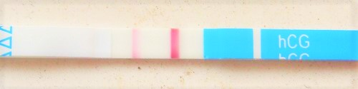
Figure 16 hCG strip for pregnancy test

VENEREAL DISEASE RESEARCH LABORATORY {VDRL}
The venereal disease research laboratory {VDRL} test is designed to assess whether or not an individual has syphilis, a sexually transmitted infection. Syphilis is caused by the bacteria Treponema pallidum. The bacteria infect by penetrating the lining of the mouth or genital area. The VDRL test doesn’t look for the bacteria that cause syphilis. Instead, it checks for the antibodies your body makes in response to antigens produced by cells damaged by the bacteria. Antibodies are a type of protein produced by your immune system to fight off invaders like bacteria or toxins. Testing for these antibodies can enable a lab scientist know whether an individual has syphilis.

PRINCIPLE: The syphilis ultra-rapid strip is a qualitative membrane immunoassay used for detection of Treponema pallidum antibodies {IgG and IgM} in serum. After a specimen is added to the test pad, it reacts with syphilis antigen coated particles; the mixture migrates chromatographically along the strip and interacts with mobilized syphilis antigen. If the sample contains Treponema pallidum antibodies a colored band appears in the test and control window of the strip indicating the result is positive while if there are no antibodies, a colored band will appear only at the control region indicating a negative result.
MATERIALS: serum from patient blood sample
APPARATUS: VDRL test strip, pasture pipette

PROCEDURE:
- I spun the blood sample in the centrifuge
- I removed the test strip from the pouch and placed it on a flat surface
- Using a pasture pipette, I introduced about 2-3 drops of the prepared serum from the patient’s blood sample on the already set test strip
- Then I allowed the serum migrate along the test strip for about 5-1O minutes.
- I observed the strip for the appearance of the colored band(s).
- The result was interpreted not less than 3 minutes and not more than 3O minutes.

OBSERVATION / RESULT:
A RED bar on both the Test and Control bands of the strip indicates a POSITIVE Test.
A RED bar only on the Control band without any on the Test band indicates a NEGATIVE Test.
A RED bar only on the Test band without any on the Control band indicates an INVALID Test.
No RED bar at all on both the Test and Control bands indicates an INVALID Test.

- RETROVIRAL SCREENING (RVS) TEST
Retro-Viral Screening test is a test that looks for HIV antibodies in your blood or saliva. The immune system makes antibodies when you are exposed to bacteria or viruses like HIV.
HIV- Human Immunodeficiency Virus: This is a virus that attacks cells that help the body fight infection, making the person more vulnerable to other infections and diseases.
The virus can be transmitted through:
- Pregnancy
- Breast feeding
- Blood transfusion
- Human bite
- Unprotected sex
HIV is in the red cell while the antibody is in the serum/plasma.
HIV strip has antigen which reacts with the antibodies in the serum. In the test strip it has patient and control line.
AIM: To screen for HIV ½ antibodies in patients’ serum.
MATERIALS: Patient’s blood sample, centrifuge, HIV – ½ star-pack kit, timer, hand gloves.
PRINCIPLE: If antibodies to HIV-1 & HIV-2 are present in the sample, the antibodies bind to the antigen-selenium colloid and to the antigen at the patient window, forming red bands at the patient window site.

PROCEDURE:
For serum or plasma samples.
- Remove the protective foil cover.
- Apply 50µl of sample to the sample pad.
- Wait a minimum of 15mins and read results.
For whole blood sample.
- Apply 50µl of sample to the sample pad (marked by the arrow symbol).
- Wait 1min, then apply one drop of chase buffer to the sample pad.
- Wait a minimum of 15mins and read result.

INTERPRETATION OF RESULTS
RESULT | INTERPRETATION
The presence of bands on both the test and control field | Positive
The presence of a single band at the control field | Negative
The presence of no visible bands | Invalid

PRECAUTION
Always read out the result under sufficient light to avoid error.
Ensure that no test strip is re-used, discard after each use.
Do not use the test kit beyond the expiry date.
Wear your protective laboratory coat and hand gloves.
Do not use kit if the pouch is punctured or not well sealed.

NOTE: a colored band should always appear on the control region of all tests involving use of immune chromatographic test strips showing that the test is functioning effectively.

MALARIA PARASITE TESTING (CASSETTE METHOD)
Malaria P. f/P. vAb test is an immunochromatographic rapid test for the qualitative detection of antibodies of all isotypes (IgG, IgM, IgA) specific to Plasmodium falciparum and Plasmodium vivax simultaneously in human whole blood, serum or plasma.

AIM: To conduct malaria parasite testing using the cassette method and determine and determine the presence of plasmodium antigens in blood samples.
PRINCIPLE: The malaria P.f/P. v test pack contains a membrane strip which is pre-coated with recombinant malaria P.f capture antigen (MSP, CSP) in the region of test line 1 (lower T) and with recombinant malaria P. v capture antigen (MSP, CSP) in the region of test line 2 (upper T). The recombinant malaria P.f/P. v antigen (MSP, CSP) – colloidal gold conjugate and blood specimen moves along the membrane chromatographically to the test region 1, 2 (lower and upper T) to form a visible line as the antigen-antibody-antigen god particle complex with high degree of sensitivity and specificity.
MATERIALS: These are already contents of malaria test kit; individually foil sealed device (cassette), diluent (clearing fluid) in a plastic vial format, plastic blood collection pipette, alcohol swab, lancet, instruction sheet.

PROCEDURE:
- I removed the cassette from its pouch and placed it on a flat surface.
- I cleansed the tip of a finger with a sterile swab and dried it with a clean tissue.
- With a finger pricking device I carefully pricked the tip of the finger that was swabbed (at the side) squeezing gently to increase blood flow.
- I applied end of a capillary tube to the blood flow to draw blood into the tube till filled.
- Holding the capillary tube in a vertical position I immediately applied the blood from the tube into the center of the cassette sample.
- I allowed the blood to absorb for about 30 seconds.
- I added 5 drops of the reagent (diluent) into the sample well.
- I waited for about 10-15 minutes before reading the result.
RESULT: The test is negative if only the control line (C) appears. The test is positive if 2 or 3 lines appear in the test window. The test is invalid if the control line (C) does not appear and must be repeated.
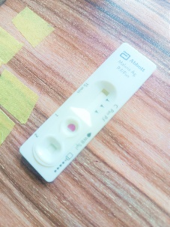
Figure 17 Malaria test pack

CLINICAL CHEMISTRY SECTION
Clinical chemistry is also known as chemical pathology. It is the area of clinical pathology which generally concerned in measuring levels of chemical components in the body fluid.
The most common specimen tested in clinical chemistry are blood and urine. Many different tests exist to test for almost any type of chemical component in blood or urine. Components may include; urinalysis, blood glucose, electrolytes, enzymes, hormones, lipid (fat), other metabolic substances, and proteins.
In my place of attachment, I was exposed to the following tests under clinical chemistry. They include:
- Urinalysis
- Stool analysis
- Faecal occult blood test(FOBT)
- Blood sugar

URINALYSIS
Urinalysis is a group of manual and/or automated qualitative and semi-quantitative test performed on a urine sample. Routine urinalyses are performed to detect renal and metabolic disease, diagnose diseases or disorders of the kidneys or urinary tract and monitoring of patients with diabetes. Normally, a mid-stream clean catch urine specimen is preferable for this test to yield a good result, and must be collected aseptically in a sterile container and well covered before the test.
Routine urinalysis consists of three testing groups
- Macroscopic (Physical) Examination
- Biochemical Examination
- Microscopic Examination

MACROSCOPIC EXAMINATION OF URINE
Macroscopic/Physical urine test measure the colour, transparency (clarity) and specific gravity of urine sample.
- COLOUR: Normal urine is straw yellow to amber in colour. Abnormal colour include bright yellow (may be caused by bilirubin), brown (caused by excessive urobilinogen or prophobilin).
- TRANSPARENCY: Normal urine is transparent. Turbid urine may be caused by either normal or abnormal processes. Normal conditions giving rise to turbid urine include precipitation of crystals, minus or vaginal discharge. Abnormal caused of urine turbidity include presence of blood, yeast, and bacterial
- SPECIFIC GRAVITY AND ODOUR: urine with pungent smell of Ammonia may be due to breakdown of urea by bacterial, fruity smell may be due to the presence of ketone. Production of foul odor might be due to the presence of Urinary tract infection.

BIOCHEMICAL EXAMINATION OF URINE
Biochemical testing of urine is performed using reagent strips, often called dipstick. A urine dipstick consists of a white plastic strip with absorbent microfiber cellulose pads attached to it. The test strip is dip into the urine, let it sit for a specified amount of time, and compares the colour change to a standard chart. During my SIWES, I used medi-combi-9 test strip for urinalysis and it test for 9 parameter which are outlined below:
- Blood (Hematuria): Red cells and hemoglobin may enter the urine from kidney or urinary tract. Testing for blood detects abnormal level of red cells or hemoglobin caused by excessive red cell destruction, kidney or urinary tract infection, or urinary tract injury.
- Bilirubin: Bilirubin is a breakdown of hemoglobin. Bilirubin in urine is defined or conjugated by the liver and a positive test indicates hepatic disease or hepatobiliary obstruction.
- Nitrite: Some disease bacteria, including the lactose-positive Enterobacteriaceae, staphylococcus, proteus, pseudomonas and salmonella are able to reduce nitrate to nitrite. A positive test for nitrite indicates bacteriuria.
- Leukocyte: The presence of white blood cell is in urine usually signifies a urinary tract infection, such as cystitis or renal disease such as pyelonephritis or glomerulonephritis.
- Ketone: Ketones are compounds resulting from the breakdown of fatty acids in the body. Ketones are found in urine in several in cases like fever, pregnancy, glycogen storage diseases, and weight loss produce by carbohydrate restricted diet.
- Urobilinogen: Urobilinogen is a substance formed in the gastrointestinal tract by bacterial reduction of conjugated bilirubin. Increased in urine urobilinogen causes hepatitis, Prehepatic Juridic and other forms of hepatic necrosis that impair the circulation of blood in liver and surrounding organs.
- PH: A combination of indicators (methyl red and bromythol blue) react with hydrogen ions (H⁺) to produce a colour change over a PH range of 5.0 to 8.5. PH measurement are useful in determining metabolic or respiratory disturbances in acid-base balance.
- Glucose (Sugar): The glucose test is used to monitor persons with diabetes. When blood glucose level rise above 160mg/dl, the glucose will be detected in urine.
- Protein: This test uses a PH indicator, such as tetra bromphenol blue, that changes colour (at constant PH) when albumin is present in urine. This test determines the presence of glomerular damage.
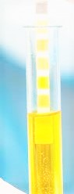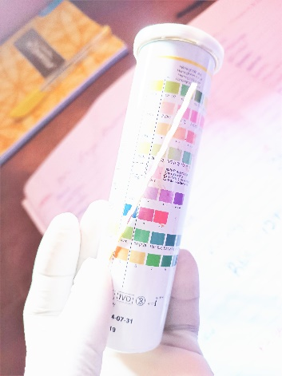
Figure 18 Combi 9 dipped in a urine for chemical reaction

MICROSCOPIC EXAMINATION OF URINE
A urine sample may contain cells that originated in the blood, the kidney or the lower urinary tract. Microscopic examination of urinary sediment can provide valuable clues regarding many diseases and disorders involving these systems. The presence of bacteria or yeast and white blood cells helps to distinguish between a urinary tract infection and a contaminated urine sample. White blood cells are not seen unless if the sample has been contaminated. The presence of cellular casts (Casts containing RBCs, WBCs, or epithelial cells) identifies the kidneys rather than the lower urinary tract, as the source of such cells.
Cellular casts and renal epithelial (kidney lining) cells are signs of kidney disease. Microscopic examination also identifies both normal and abnormal crystals in the sediment. Abnormal crystals are those formed as a result of an abnormal metabolic process and are always clinically significant. Normal crystals are formed from normal metabolic processes; however, they may lead to the formation of renal calculi or kidney stones. The urine sample is collected in a sterile container with a tight-fitting lid, after the genitalia have been cleansed using the midstream void (clean-catch) method, it is spin in a centrifuge, decant the supernatant, then a drop of the sediment is placed on the Centre of a microscopic slide, cover with cover slip, and view under the microscopic, using x10 objective lens to focus and x40 objective lens to view clearly for yeast cells, cast, epithelia cells, bacterial cells, pus cells, red blood cells etc.
STOOL ANALYSIS/MICROSCOPY
Stool analysis is used in the diagnosis of gastrointestinal tract infection. Stool analysis includes; macroscopy, and microscopy. Macroscopy is the one observed with unaided eye, while microscopy is one observed using microscope and cannot be seen with unaided eye.
PRE-ANALYTICAL SAMPLE COLLECTION
- A wide–mouthed container was provided.
- The patient was educated on proper sample collection. Noting important requirements like:
- Avoid using and wrapping the stool on tissue paper leaf.
- Avoid mixing the stool with urine.
- Avoid keeping the sample for long time over 4hrs before presenting it for examination.
PRINCIPLE: Stool analysis is vital for diagnosing infections, detecting gastrointestinal bleeding, assessing digestive disorders, monitoring treatment efficacy, and evaluating overall gastrointestinal health.
AIM: To detect and identify the presence of parasites in the stool sample.
MATERIALS: Microscope, clean grease-free slide, cover slip, physiological saline, Lugol’s iodine, applicator stick, methylene blue solution, acetic acid 50% solution, eosin 2% solution in saline or field B.
MACROSCOPY
PROCEDURE:
- The consistency (degree of moisture, and note whether it is formed, unformed, soft, or semi-formed, loose or watery) was checked.
- The colour (appearance) of the sample was noted. Normal stool of adults is usually brown while infant stool is yellow-green or gray.
- Presence of mucus, blood stain, adult worm and pigment were also noted.
MICROSCOPY/WET PREPARATION TECHNIQUE
PROCEDURES:
- A drop of fresh physiological saline was placed on one end of a grease-free slide and a drop of iodine was placed on the other end.
- An applicator stick was used to emulsify a small amount of stool specimen about 2mg with the saline and similar amount with the iodine.
- A smooth thin preparation was made and each was covered with a cover slip. Air bubbles were avoided.
- The entire saline preparation was examined systematically, parasite, larvae, ciliates, helminthes, eggs, cysts, and oocyst using ×10 objective with condenser Iris closed sufficiently to give a good contrast. Use ×40 objective to assist in the identification of ova, cyst, and oocyst.
- The iodine preparation was used to assist in the identification of cysts.
PRECAUTIONS:
- It was ensured that over floating was avoided by using a small drop of saline & iodine.
- It was ensured that different areas of the specimen were touched for adequate representation of all parts of the specimen before mixing with saline or iodine.
- It was ensured that too much specimen was not used, otherwise the preparation would be too thick, making it difficult to detect and identify parasites.
FAECAL OCCULT BLOOD TEST (FOBT)
Faecal Occult Blood is (FOB) is the presence of blood in the stool that that is not visibly apparent. The detection of occult blood is vital in identifying potential gastrointestinal issues, with the Faecal Occult Blood Test (FOBT) being a key diagnostic tool.
AIM: To detect the presence of occult blood in stool of a patient using test strip.
PRINCIPLE: The principle is an immunochromatographic sandwich method, which employ two specific monoclonal antibodies to selectively identify hemoglobin in the test samples. The test strip is designed to detect lower levels of colorectal bleeding. It has the ability of detecting about 100ng/ml hemoglobin in faeces. The strip has two result regions, one as control and the other as test. The chemical reaction becomes visible by appearance of colour and only red colour in control side. It shows negative.
MATERIALS/APPARATUS REQUIRED: Stool sample, occult test strip, buffer solution
PROCEDURES:
- A stool sample was collected from the patient.
- With the aid of a sterile stick, a small quantity of the stool was inoculated into the buffer solution and mixed properly.
- The test strip was inserted and allowed for some minutes.
- The result was read after about 5 minutes.
RESULT INTERPRETATION:
- Positive result: when there is line in both the control and the test area.
- Negative result: when there is only one line at the control region.
- Invalid: when only one line at test region or no line at both test and control regions.
CONCLUSION: Occult blood in feaces was detected using test strip method.

PRECAUTIONS:
- It was ensured that result was read within 10 minutes.
- It was ensured that the sample was properly shaked before dipping the strip.
- It was ensured that the test strip used has not expired.
CLINICAL SIGNIFICANCE: Detection of fecal occult blood test is used in diagnosis and treatment of ulcer. This blood is occult (hidden) and cannot be seen with naked eye. Ulcer is a break in the skin extending to all its layers, or a break in the mucous membrane lining the alimentary tract, that fails to heal and is often accompanied by inflammation. When there is bleeding in the colon or rectum, it mixes up with stool and this test helps to detect the bleeding.
Fecal occult blood test is usually carried out for the investigation of the cause of iron deficiency anaemia and in diagnosis of bleeding lesion of the gastrointestinal tract e.g. peptic ulcer; carcinoma erosive gastritis due to alcohol or drugs.

BLOOD SUGAR TEST
Blood sugar test is the test conducted on a patient (either male or female) to measure the level of glucose in the blood. Glucose is the main form of energy that the body requires and so it is maintained within a narrow range by the body. However, an elevated glucose level is a silent disease that can cause extensive damage if not treated. Timely testing to know when it is high or low helps to catch the disease early and keeps it well controlled. It is mainly carried out to diagnose diabetes, to check whether diabetes (if present) is properly managed and also check for drop or rise in blood sugar level.

TYPES OF BLOOD SUGAR TEST
Some types of blood sugar test include;
i) Fasting blood sugar test
ii) Random blood sugar test
Fasting blood sugar test this is done very early in the morning before eating, usually before 10:30am. Here the patient doesn’t eat before the test done. While random blood sugar test is done on a non-fasting patient. Therefore, it can be done at any time of the day. The procedure is the same, but with different range.
PRINCIPLE: A blood glucose test measures the amount of glucose, or sugar, in your bloodstream. Its most often used to screen for diabetes. Blood glucose tests can be fasting or random. Fasting tests provide the most accurate results and are easier to interpret than random tests. A blood glucose test can help determine how well your diabetes is managed if you’ve already been diagnosed with diabetes.
MATERIALS: blood sample
APPARATUS: glucometer and glucometer test strips, lancet, swab

PROCEDURE:
- The glucometer strip was first inserted into the machine and allowed to set.
- After the above step, I cleaned the finger of the patient to be pricked with alcohol {ethanol} and allowed to dry. The thumb or middle finger [flow finger} can be pricked.
- Then I pricked the site using a lancet.
- Afterwards I introduced a little drop of blood on the test area of the strip.
- I allowed the machine for 10 seconds and then read the result.

REFERENCE RANGE
Fasting blood sugar test > 67- 123mg/dl or 3.7-6.8mmol/l
Random blood sugar test >
Any other value obtained that is higher than the given range shows possibilities of that individual having diabetes mellitus
NB: when blood glucose is low, it is called hypoglycemia while a raised blood glucose level is called hyperglycemia.
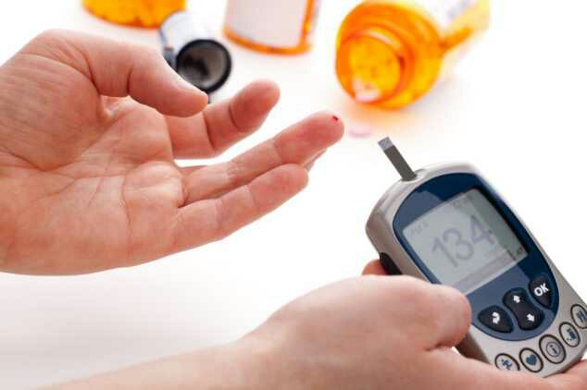
Figure 19Glucometer reading a blood sample

MICROBIOLOGY SECTION
Microbiology involves the study of microbes. Although, microorganisms are generally beneficial and essential to life some are, however, pathogenic and causes infectious diseases. The diagnostic microbiology laboratory is engaged in the identification of infectious agents. These infectious agents are broadly classified as viruses, bacteria, mycostic agents and parasites (Protozoans and Helminthes), also this section analyses body fluids and tissues for the presence of pathogenic microorganisms primarily by means of microscopy, culture and sensitivity (MCS). Results of the MCS tell the physician the type of organisms present as well as the particular antibiotic that would be most effective for treatment.

HVS MICROSCOPY
A high vaginal swab (HVS) is a medical procedure performed in Obstetrics and Gynecology, to commonly test for the presence of vaginal thrush, Bacterial vaginosis and Trichomonas vaginalis. It is carried out under aseptic conditions, by a healthcare professional, who uses a speculum to visualize the vagina.
AIM: To test for the presence of vaginal thrush, bacterial vaginosis and trichomonas vaginalis.
PRINCIPLE: It involves the microscopic examination of the swab sample taken from the high vaginal area. This method aim to identify and assess the presence of microorganisms, such as bacteria, yeast, or other cellular abnormalities, aiding in the diagnosis of vaginal infections and providing valuable insights into women’s reproductive health.
MATERIALS: HVS swab stick, microscope slide, cover slip, microscope, normal saline.
PROCEDURE:
- Insert the swab to the top of the vagina and rotate to obtain a sample of the discharge.
- Put a drop or two of normal saline on a microscope slide and dip the swab into it to absorb the discharge.
- Place a cover slip on it
- Place under the microscope to view possible cells and detect infection.

SPUTUM MICROSCPY
Sputum microscopy is a diagnostic test used to examine sputum samples under a microscope to detect and identify microorganisms, such as bacteria, fungi, or parasites, that may be causing respiratory infections or diseases. It is commonly used to diagnose conditions like tuberculosis, pneumonia, bronchitis, and other respiratory tract infections.
AIM: The aim of sputum microscopy is to identify and characterize microorganisms present in sputum samples to aid in the diagnosis and treatment of respiratory infections and diseases.
MATERIALS: Sputum sample container, microscope, microscope slide, immersion oil, stains, Bunsen burner.
PRINCIPLE: Sputum microscopy relies on the visualization of microorganisms present in sputum samples using a microscope. Different stains are used to highlight specific types of microorganisms. For instance, the Gram stain helps differentiate bacteria into Gram-positive and Gram-negative categories based on their cell wall composition. The Ziehl-Neelsen stain specifically stains acid-fast bacilli, which are characteristic of Mycobacterium tuberculosis, the causative agent of tuberculosis. Other stains are used to identify fungi or parasites present in the sputum sample.
PROCEDURE:
- The patient is asked to cough deeply to produce sputum from the lower respiratory tract. The sputum is then collected into a sterile container
- A small amount of the collected sputum is spread thinly and evenly onto a clean microscope slide.
- The slide with the sputum smear is heat-fixed by passing it through the flame of a Bunsen burner or other heating source. Heat fixation kills the microorganisms present on the slide and helps them adhere to the slide.
- Different staining techniques are used depending on the suspected microorganism.
- The stained smear is examined under the microscope using various magnifications to observe and identify the microorganisms present.
- The presence, type, and quantity of microorganisms are noted and interpreted in conjunction with the patient's clinical symptoms and other diagnostic tests to establish a diagnosis and determine appropriate treatment.

CULTURE AND SENSITIVITY ANALYSIS
Culture and Sensitivity analysis, also called susceptibility testing, helps the doctor find the most effective antibiotic to kill an infecting microorganism. Infecting microorganisms are organisms such as bacteria or fungi that invade your body and cause an infection. A sensitivity analysis is a test that determines the “sensitivity” of bacteria to an antibiotic. It also determines the ability of the drug to kill the bacteria. The results from the test can help the doctor determine which drugs are likely to be most effective in treating your infection.
Doctors use sensitivity testing to determine the right antibiotic treatment for an infection and to monitor changes in bacterial resistance to antibiotics. Both are key to your care.
CULTURE ANALYSIS/ TEST
AIM: To isolate the possible microbe present in the given sample.
MATERIALS: sample (Sputum/urine//HVS), Bunsen burner, agar (depending on expected isolate), wire loop, Petri dishes, incubator set at 37
PROCEDURE:
- Prepare agar (MacConkey) for bacteria, following manufacturer's description. (any other preferably agar for bacteria can be used)
- Allow to cool to 45 degrees and dispense into the petri dishes.
- Inoculate the urine by use of the wire loop after sterilizing over flame/ inoculate the HVS by rubbing over the surface of the medium
- Incubate for bacteria at 37 degrees for 24 to 48hrs
- After 48 hours, a growth appears.
RESULT:
- E.coli will have a growth of pink colonies
- Aerobacter aerogenes will appear pink and mucoid
- Enterococcus species will appear pale pink, minute and round.
- Staphyloccoccus species will appear pale pink and opaque
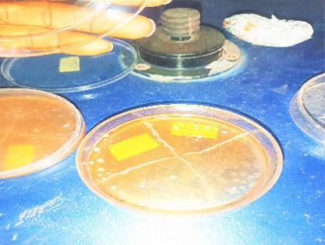
Figure 20 culture inoculation
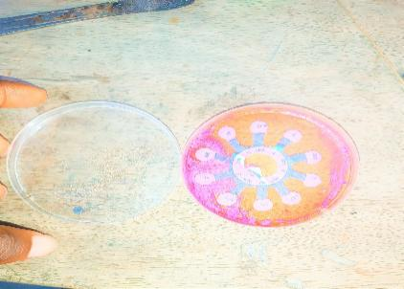
Figure 21 Culture sensitivity

MICROSCOPY
AIM: To identify organisms under the microscope.
MATERIALS: Glass slide, cover slip, microscope, sample (like urine and HVS) and dropper.
PROCEDURES:
- Sterilize the glass slide then use a dropper to get a small amount of the sample
- Then use a dropper to get a small amount of the sample on the slide.
- Place it on the stage of the microscope.
- View the sample using 40x or 100x lens
- If the sample appears too turbid use a coverslip to place on top of the sample to make it clearer, prevent it from drying and to reduce motility.
NOTE: Normal saline can be added to the sample before placing the cover slip so as for it to help demonstrate motility.

ORGANISMS SEEN UNDER THE MICROSCOPE AND THEIR MEANING
EPITHELIAL CELLS: Epithelial cells are cells that lines the urinary tract. The presence of epithelial in the urine sediment can indicate a variety of conditions such as inflammation, infection or injury to the urinary tract.
CRYSTALS: Crystals in the urine sediment can indicate a variety of conditions such as dehydration, kidney stones or a urinary tract infection.
PUS CELLS: Pus cells or white blood cell are typically round and appear as spherical or irregularly shaped cells under a microscope. They may contain granules or vacuoles, which can give them more distinct appearance.
BACTERIA CELLS: Bacteria cells in urine sediments can indicate a bacterial infection in the urinary tract .Bacteria may appear in different shapes including cocci (spherical), bacilli (rod-shaped) etc. Some bacteria may also appear as clusters or chains under the microscope.
RED BLOOD CELLS (RBCs): RBCs in urine sediments can indicate a range of conditions, such as bladder or kidney infections, kidney stones or cancer.
CASTS: Casts are formed in the kidney tubules and can indicate various kidney diseases.

CHAPTER FOUR

SUMMARY OF TRAINING EXPERIENCE
My Industrial Training period was a huge success, full of educative and filled with great adventures. I learnt more laboratory and working ethics, generally I was able to appreciate my course of study and I saw its vital role when it comes to the health of individuals. Being able to merge the theoretical knowledge acquired in my institution with the practical aspect boosted my productivity in the laboratory. I was thought Laboratory and work ethics, mode of approach to patients, how to handle work pressure, self-confidence, leadership potential, adaptability, tolerance, and punctuality. This experience has given me a broader view to the importance and relevance of Microbiology.
These experiences gathered have helped mold me into a work ready lady as I graduate from school and appreciate the connection between my course of study and other disciplines in producing an awesome result.

DIFFICULTIES ENCOUNTERED
Some of the major problems encountered are:
- Securing a place of attachment: Most companies and health organizations reject SIWES students, others prefer medical laboratory science students more than we studying microbiology based on reasons best known to them.
- Transportation: My place of attachment was far from where I live on that, it passed a great challenge to me.
- Impatient patients: I had to deal with impatient patients too, and which was frustrating at times. They are not ready to understand any excuse you have to give and are always ready to yell at you when you mention the price of a particular test. It was very stressful, I barely had time for myself.

RECOMMENDATION
- SIWES management should put more effort in relating with co-operate firms to accept students for industrial training.
- They should ensure that little payment is made to the industrial trainees so as to motivate and encourage them.
- SIWES management should also work hand-in-hand with co-operate firm management to make sure that safety gadget is made available to industrial trainee on individual basis to avoid risking their lives to hazardous chemicals.
- Co-operate firm’s coordinator should ensure that the industrial trainees are well trained and given an appropriate answer to their questions accordingly

CHAPTER FIVE

CONCLUSION
In conclusion as a microbiology student, I have been able to have a great experience of what it feels like to merge both practical and theoretical knowledge together. I have been able to obtain an effective practical industrial training and experience within the space of six months {6months} having been exposed to practical activities.
With my experience-filled period of Industrial Training, I have learnt how to appreciate my course of study (Microbiology) more; as I have also acquired vital interpersonal skills with the opportunity given me to explore the work environment, laboratory responsibilities and ethics. With this, it is of no doubt to me that I can comfortably into any work environment I find myself after my graduation.
Finally, The SIWES programme is of immense benefit to the Nigerian students. Thus, the Federal Government through the Industrial Fund (ITF), should adequately fund the programme as this will contribute to nation building.

REFERENCES
American society for clinical pathology (ASCP): 2100 West Ahrrison Street, Chicago, II 60612-3798. (312) 738-1336. http://www.ascp.org.
Ash, O. R. and Oriel, T. C. (2007). Atlas of Human Parasitology, 5th edition. American Society of Clinical Pathology Press, USA, pp. 25-40.
Chemecky, I., Cynthia, C. and Barbara, J. B. (2001). Laboratory Tests and Diagnostic Procedures, 3rd edition. Saunders Company, Philadelphia, USA, pp. 92-109.
Chesbrough, M. (2006). District Laboratory Practice in Tropical Countries, part 1. Cambridge University Press, Cambridge, UK, pp. 340-368.
Chesbrough, M. (2006). District Laboratory Practice in Tropical Countries, part 2. Cambridge University Press, Cambridge, UK, pp. 45-363.
Collins, C. H., Grange, J. M. and Yates, M. D. (1997). Tuberculosis bacteriology, 2nd edition. Butterworth Heinemann Press, New Delhi, India, pp. 413-417.
Dhruba, G., (2016): Bacteriology, Microbiology. “Colorectal cancer screening” Web MD. [hhtp://my.webmd.com/ content/ article/ 2955.291]
Eberhard M., and Lammie P. (1991) Laboratory diagnosis of filariasis. Clin Lab Med; 11:4.
Elizabeth H. and Holt, MD, Ph.D. (2009): AB Medlimplus > Blood glucose monitoring updated date: 6/17/2008. Updated in turn citing. American Diabetes Association. Standards of Medical care in diabetes. Diabetes care; 31: S12 – S54.
Fecal Occult Blood Test; Virtual Health Fair. July 10, 2001.
Fecal Occult Blood Test; Virtual Health Fair. July 10, 2001.
Kee, Joyce L. F. (2001): Handbook of Laboratory and Diagnostic tests, 4thedr upper saddle River, N.: Prentice Hall.
Kee, O. and Joyce L.F. (2001). Handbook of Laboratory and Diagnostic Tests, 4th edition. Upper Saddle River Press, Paris, France, pp. 60-78.
Lane, Takhar, S. S. (2011). “Diagnosis and Management of urinary tract infection and pyelonephritis”. Emergency medicine clinics of North America. 29(3): 539-52. Doi: 10.1016/j.emc. 2011.04.001. PMID 21782073.
Lewis, S. M., Bain, B. J. and Bates, I. (2006). Practical Haematology, 10thedition. Georgia University Press, Georgia, USA, pp.155-205.
Lippincoh W., Wilkins, Devita, V.; Samuel H., & Steven R. (2001) Cancer Principles and practices of Oncology. Philadelphia.
Mcherrow, J. and Parslow, T.G. (2001). Medical Immunology of 10th edition. Parslow TG et al (editors), USA, pp. 10-35.
Mireles, AL; Walker, JN; Caparon, M; and Hultgren, S. J. (May 2015): “Urinary tract infections; epidemiology, mechanisms of infection and treatment options: Nature reviews. Microbiology 13(5):269 – 84 d01:1038/nrmicro 3432. PMID 25853778.
Monica C. B. (1998): Distinct laboratory practice in tropical countries part two (2).
Norgram, A. P., Arguello H., Sloan L. M., Fernholz E. C., Pritt B. S. (2013) Malaria Journal 12:231.
Ochei, J., and Kolhatkar, A. (2001): Medical laboratory sciences, theory and practice
Provan, D. (2004). Oxford Handbook of Clinical Haematology, 2nd edition. Oxford University Press, USA, pp. 25-30.
Retrieved 9 February 2016 “Urinary Tract Infection”: CDC April 17, (2015).
Ridley, M. J. and Ridley, D.S. (1971). Stain Techniques and Morphology of Mycobacterium laprae, 2nd edition. Brooklyn Cage Press, pp.88-95.
Tankeshwar, A. (2002): A medical laboratory for developing countries. Maurice king bacteriology, culture media used in microbiology, laboratory diagnosis of Bacterial diseases.

